Rowhedge Allotments Committee Meeting Agenda
Wednesday 24th July 2024 at 6.30pm
The Albion

Present: Janet (Chair), Caroline, Paul, Zoe H, Martin, Carol, Katrina, Penny, Zoe M, Guy, Sarah.
Apologies: Debbie, Dave

- New website
Everyone agreed that the new website developed by Caroline is very user friendly and covers everything needed. It will be ready to launch shortly. All documentation from prior to 2024 from the old website is being transferred to the archive so will still be available. Caroline will meet with Christian prior to changeover to ensure smooth transition. There is a news and events section where activities such as the willow weaving workshop and a possible seed swap event can be advertised there as well as on social media.
Actions: Caroline will share again with the committee prior to launch. Any issues or corrections, please et Caroline know asap so changes can be made.
Caroline will share log ins so that documents can be uploaded.
Plot map to be included.

- Water pumps
A change has been made to the original draft. An annual charge will be made for licence to use a water pump - £20 half plot and £40 full plot. The pumps should only be used with a hose to fill a water butt, not to water direct with a hose.
Actions: Caroline will finalise the section on the website and send a link.
Once website is launched Sarah will send out an email about the website , drawing particular attention to the changes to water pumps, plot inspection process, no use of chemicals harmful to wildlife and tenancy agreements.
Paul will continue to monitor water use and this will need to take into account increased use resulting from the new plots.

- Wild parsnip removal
This needs to be controlled. Janet has produced a poster of poisonous plants and Zoe M has put posts on social media. Plotholders need to be encouraged to remove asap.
Actions: Sarah to send out another email and include poster and request to deal with asap. Poster to go on new noticeboard when available.

- Plot inspection process and letter distribution. Once the website is launched with the updated inspection procedure, Sarah will send out the email highlighting this so everyone is aware prior to letters being sent. A further inspection will then take place and letters will be posted to holders of allotments giving cause for concern.
Actions: Janet and Caroline to finalise letters.

- National Allotment Society letter
The NAS letter on need to register with HMRC was revisited as we need to decide on a course of action. Katrina stated that Dave has previous experience of this issue and can explore a solution.
Actions: Dave to explore with EDPC and feedback to Committee.

- Skip
It was agreed that at least one skip is needed to clear the rubbish on the woodpile. The furniture also needs removing as some of it is rotten. It was agreed that one skip is ordered initially and Paul and other volunteers put all the stuff already on the pile in before advertising more widely to plotholders to ensure it is not filled with rubbish from outside the allotments. An email has already gone out to plotholders asking them not to put other rubbish on the woodpile. This needs reinforcing.
Actions: Paul will order a skip for a Friday and fill it before alerting anyone. Any volunteers please join Paul.

- Thefts, trail cameras and boundary
Some onions and water butts have been taken but this appears limited to a singular plot. No one else has reported.
Actions: All to consider trail camera use.

- AOB
-Woodchips have been delivered.
-Katrina has organised willow weaving workshops for September 21st and 22nd. Obelisk/ plant support morning £55; Ornament afternoon £25: all day £75.
Actions: Once details confirmed, Katrina will send to Sarah and Zoe M for sharing with plotholders by email and social media.
-Mowing rota is still not working. Need more people on and confirmation when someone has mown. It would be good is someone else could volunteer to coordinate as Janet is now Chair.
Clearing is needed for new plots.
Actions: Sarah to email asking for volunteers to help Martin and Paul with clearance.

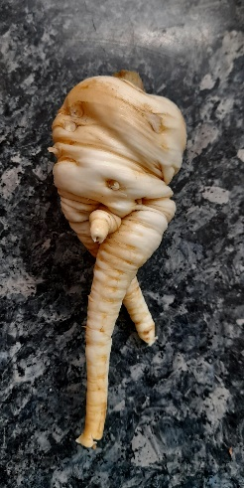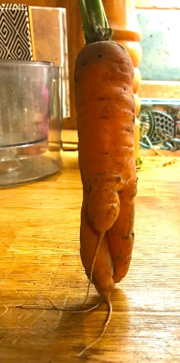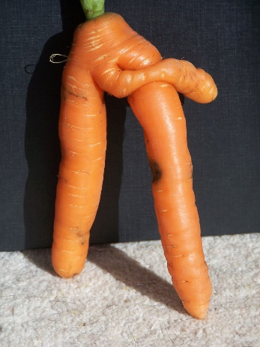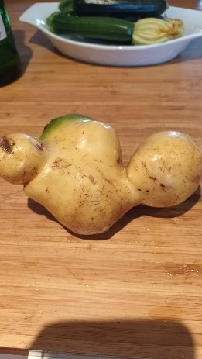
Committee photo for website

